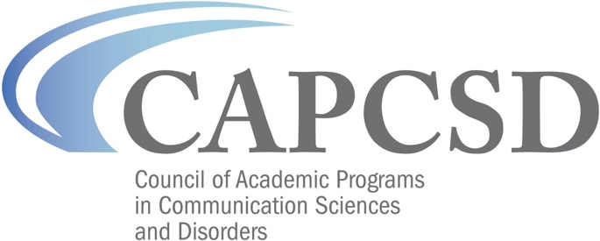
CSDCAS Open Data Initiative
Please complete the following within 30 days of completing your proposed research, which will serve as the final report to the CSDCAS Data Subcommittee.

Date:

PI and other key personnel (if applicable):

Please provide a concise description of your project/results that will be posted to the CAPCSD website:

Please describe how your results were disseminated, providing citations as appropriate:

